Protocol water stable soil aggregates

BEFORE
Notes for the soil sampling:
It is important that the soil is not squeezed. If you use a soil corer, take the inner part for soil aggregate analysis and put it in a stable container, e.g. a falcon tube. Plastic bags are not recommended as the bags will be stacked and thereby squeeze the soil.

Notes for storing after sampling:
Do not freeze the samples as this may break aggregates. Soil should be dry. Cooling for short periods is ok. It is important that no fungi grow etc. as this causes aggregation. For comparable and valuable data samples should be analized max. 14 days after air-drying.

Amount of material needed:
As the variation is high for soil aggregate measures, we take three replicates per sample. Each replicate is around 4g dry soil and was sieved before between 1 and 2 mm in the sieving tower. (If aggregation is too strong switch 2 mm to 4 mm sieves e.g. sieved fractions between 1 and 4 mm)

IN THE LAB
Materials:
Material | Location
Sieving machine with matching sieves and metal bins | C.00.08
Balance D = 0,01 | C.00.08/09
Weighing boats | C.00.08/09
Spatula | C.00.08/09
Drying oven  Beakers 150 ml  Dispersing Agent (Na₂PO₃) | C.00.09  C.00.03  C.00.15

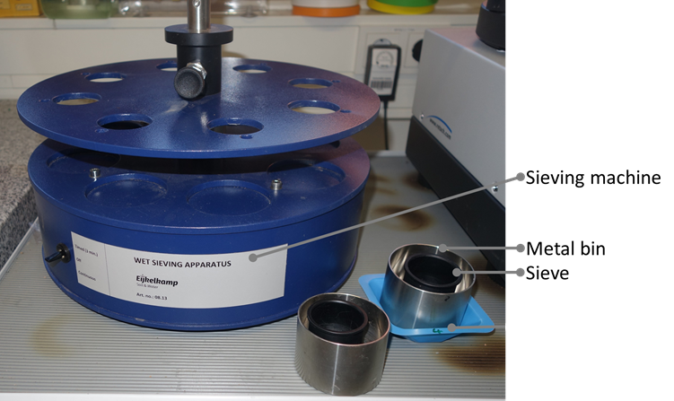

Processing:
- Put the samples on top of the 2 mm sieve and place it together with the 1 mm sieve and a bottom in the tower (up to 3 samples possible)
- Use program “1” of sieving tower
- Take the soil from the 1 mm sieves for analysis (you may have to carefully crush too large aggregates if you don’t get enough mass from the sieved sample)
- Fill metal bins of sieving machine with dest. H₂O. Use the same amount of water for all bins (75 ml)
- Prepare dispersing agent e.g. a 2,0 g/l (NaPO₃)_{n}, 0,45 g/l Na₂CO₃ solution (2 l bottle is recommended; -> later on: dispersing solution)
- Weigh two beakers for each replicate -> 1 for unstable and 1 for stable aggregates
- Place apparatus’ sieves in weighing boats on scale (tara!)
- Use sieved soil (1 mm)
- Weigh out 4 g soil, note weight. Due to high variance, it is recommended to prepare three replicates.
- Put apparatus’ sieves carefully in the machine. See that the samples are in max. possible contact with water. If soil does not soak through carefully add dest. H₂O for overall water contact, let soil soak for pre-defined time (e.g., 5 min)
- Let the machine run for 5 min. Aggregates have to tumble in water!!
- Pull sieves out of the water but leave them in the machine (sieve holder can be locked with screw)
- Take metal bins out of the machine and pour them into the beakers for unstable aggregates.
- Fill second set of metal bins with same amount of dispersing solution (75 ml)
- Place metal bins filled with dispersing solution underneath the sieves
- Let the samples soak in for at least 5 minutes
- Stir and crush remaining aggregates carefully with small spatula or rubber tip
- Repeat step 13 with the beakers for stable aggregates
- Let the samples dry overnight in the oven (105° C)

Calculation of percent water-stable aggregates of the whole sample:
- You need the following data:
  - Weight of the sample (e.g., 4g)
  - Weight of fraction 1 ( unstable aggregates)
  - Weight of fraction 2 ( stable aggregates)
  - Mass of dispersant ( when following this protocol: 0,18375 g)

[(mass of stable aggregates – mass of dispersant) / (sum of both fractions – mass of dispersant)] * 100 = % WSA
[(sum of both fractions – mass of dispersant)/(weight of the sample)]*100 = % of overall aggregates

Reference:
Kemper, W.D., Rosenau, R.C., 1986. Aggregate stability and size distribution. American Society of Agronomy- Soil Science of America, Madison, USA.
Nimmo, J.R., Perkins, K.S., 2002. Soil aggregate stabilty and size distribution. In: Dane et al. Methods of Soil Analysis. Soil Science Society of America, Inc. Madison, Wisconsin, USA.
Rieke et al., 2002. Evaluation of aggregate stability methods for soil health. In: Geoderma 428

